**Abstract:** Multi-receiver inductive power transfer systems are advantageous for different reasons such as fault-tolerant power transfer, lower semiconductor ratings and modular design. However, in parallel connected multi-receiver IPT systems, even small coupling mismatch causes major current imbalance in receivers. In this paper several different methods will be investigated and a novel fault-tolerant current balancing method will be proposed.

**Introduction:**

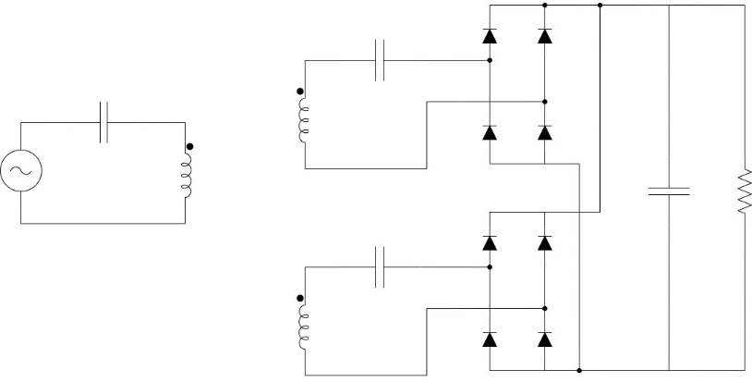

IPT system

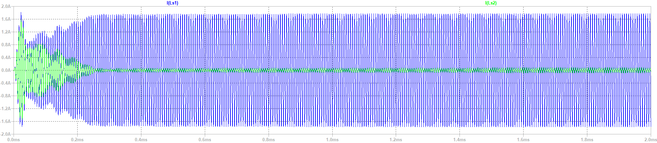

Current imbalance

*Hakan Polat, Enes Ayaz et al. makale inceleme*

*Guangdong Ning current sharing path makale inceleme*

**Proposed method:**



Proposed method

*Önerilen metodu anlat*

*teorik denklemler yazılacak*

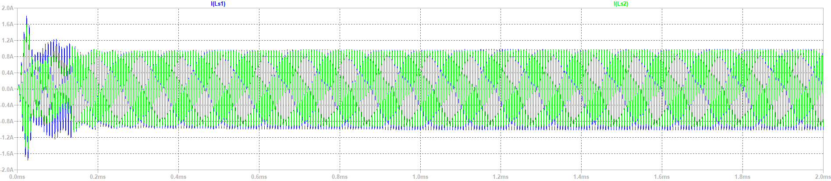

Proposed method (result)

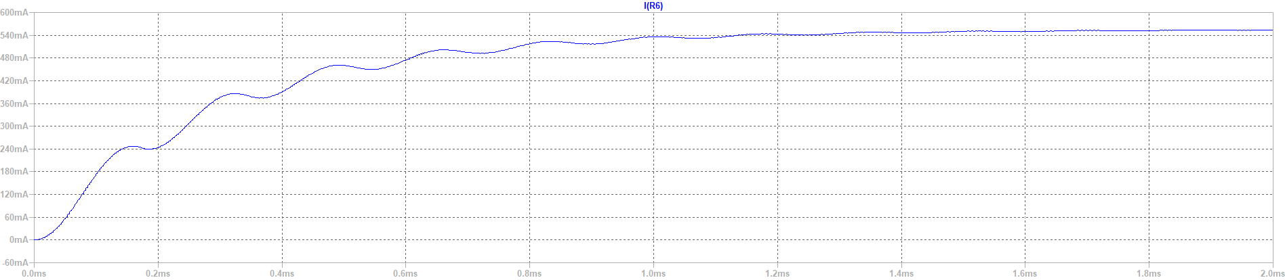

Output current with current sharing path (Guangdong Ning) (Ls1 Short)

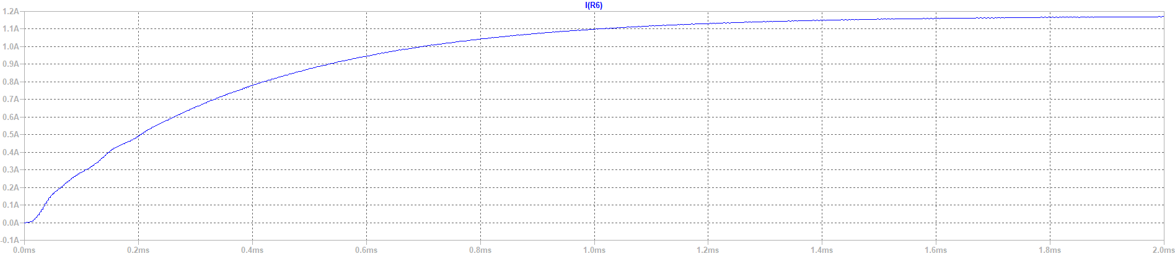

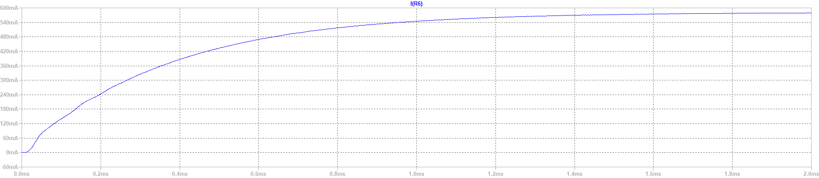

Output current with proposed method. (Full input voltage/half input voltage) (Ls1 Short)

In case of a short circuit in one of the receivers, current sharing path carries the short circuit current to other receivers which causes drop of output power/current. Also, receiver capacitors act like parallel capacitors and changes the resonance frequency.

In proposed method, short circuit current is not carried to other receivers. Resonance frequency kept constant. Output power/current can be kept constant (higher current flow on working receiver’s semiconductors) by overloading. To operate with rated currents of semiconductors, input voltage can be decreased(?). Efficiency is increased in fault mode.

*frekans değişiminin etkisine değinilebilir*

*Deney sonuçları ve fotoları konulacak*